

CHRISTMAS & NEW YEAR OPENING HOURS 2017/18
Date | Office | Tender Service | Sandbar | Harbourview  (Main Bar)
Sunday 24 December 2017 | 9am–12noon | 9am – 5pm | 8am – 6pm | 12noon–9pm
Monday 25 December 2017 (PH) | Closed | No Service | Closed | Closed
Tuesday 26 December 2017 (PH) | Closed | 8.30am – 5pm | 8am – 6pm | Closed
Wednesday 27 December 2017 | 9am-12noon | 8.30am – 5pm | 8am – 6pm | 12noon-5pm
Thursday 28 December 2017 | 9am – 5pm | 8.30am – 5pm | 8am – 6pm | 12noon–5pm
Friday 29 December 2017 | 9am – 5pm | 8.30am – 5pm | 8am – 6pm | 12noon–9pm
Saturday 30 December 2017 | 9am - 5pm | 8.30am – 5pm | 8am – 6pm | 12noon–9pm
Sunday 31 December 2017 | 9am–12noon | 8.30am – 7pm | 8am – 6pm | 12noon–9pm
Monday 1 January 2018 (PH) | Closed | 9am – 5pm | 8am – 6pm | Closed
Tuesday 2 January 2018 | 9am – 5pm | 9am – 5pm | 8am – 6pm | Closed
*Please note – opening & closing times are subject to change on daily basis.

There will be no keelboat racing between Sunday 17th December 2017 and Tuesday 2nd January 2018.
Racing commences on Wednesday 3rd January 2018 & Twilights on Thursday 4th January 2018.
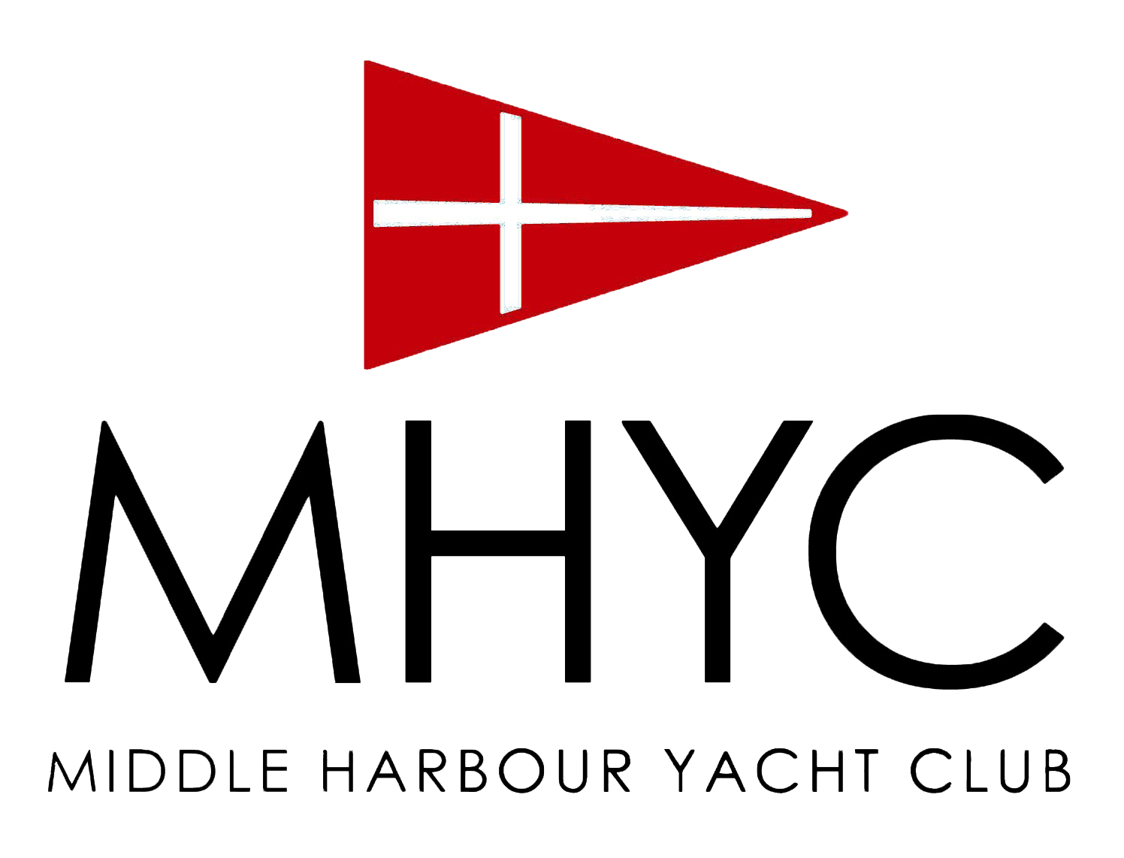
Seasons Greeting and a safe and happy new year from all the staff at Middle Harbour Yacht Club

