Kayak Rental Agreement

Full name: ____________________________________________________________________

Membership number: _________________________________________________________

Mobile: ______________________________________________________________________

Emergency contact:

Name: ________________________________________ Phone:___________________

I am renting the following:
Single Kayak Double Kayak PFD

- I understand my membership card/drivers licence will be held as a security deposit during the rental duration and will be returned upon payment of all rented equipment.

- Rentals are due back no later than 5pm on the same rental date.

- I understand that due to unforeseen inclement weather I may be required to return the rented equipment immediately as required by MHYC.

- I am responsible for the return of this equipment in the same state in which I received it. Any breakages or loss of equipment will incur replacement charges by the hirer. If equipment is not returned a recovery fee will apply.

- They kayaks are not to be taken beyond the entrance to Middle Harbour i.e. an imaginary line between Grotto Point and Middle Head.

- PFDs are to be worn at all times whilst in the kayak.

- All paddlers must be able to swim and be in reasonably fit condition. Kids must be accompanied by an adult - only 12 years and over can paddle on their own.

- I am aware of the dangers of kayaking and I understand that MHYC is in no way responsible for my safety or the safety of the equipment.

- I have read and understood the conditions of hire and agree to be bound by it. Please tick.

Signature: ____________________________________________________________________
Signature: _________________________________ Date: __________________________

Boundary of Kayak Hire

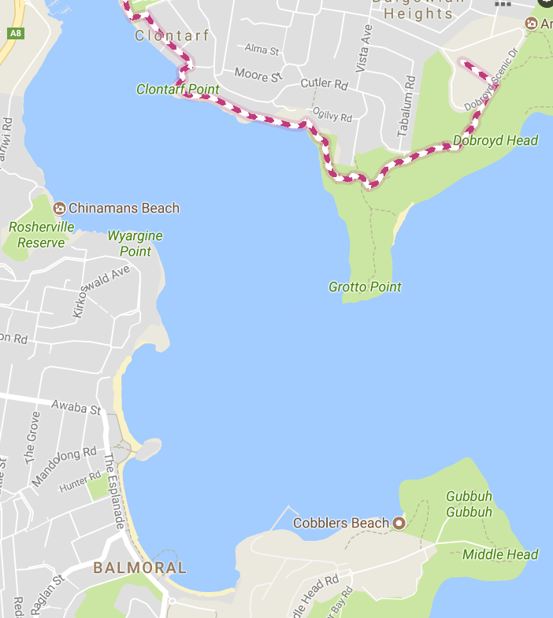

Kayak Rental Policy Document

As from September 2017, MHYC has a small fleet of kayaks (4 x single & 2 x double) which are available for Hire. This is only available to a Member or Members of MHYC, so at least one person for a booking, must be a member.
Availability 7 days a week, from 9.00 am – 5.00 pm. Bookings are recommended.
What to wear Comfortable light weight clothes are best, a hat and plastic shoes, thongs or shoes that you don’t mind getting wet. Swimming costume is always a good idea, and perhaps a light jacket in case of rain or if it is expected to be cool.
What to bring Bottled water, hat, sunglasses, towel and most important – sunscreen! You can also bring your own buoyancy vest if you have one, if not we can provide (deposit required)
Pre-requisites No paddling experience is required – beginners are welcome! All participants must be able to swim and be in reasonably fit condition. Kids of all ages are welcome, providing they are accompanied by an adult.
Special conditions All participants must sign an indemnity/agreement form prior to taking the kayaks out, and on each occasion.
Only children 12 yrs & over are permitted to paddle on their own.
It is a condition of hire that any breakages, or loss of equipment will incur replacement charges by the hirer
If equipment is not returned, a recovery fee will apply
The kayaks are not to be taken beyond the entrance to Middle Harbour, ie an imaginary line between Grotto Point and Middle Head.
Prices: 1 hour $15 single
$20 double

2 hours $25 single
$30 double

3 hours $35 single
$45 double

Up to 5 hours $50 single
$60 double

